# Data warehousing and BI systems

Car Renting

**Author:**

[First and last name]: Paloma Barreiros

[Academic year and term]: 2018 Summer Semestre

1. The aims of data warehouse implementation

This chapter should contain the list of aims that have to be achieved through the implementation of the data warehouse in the chosen part of reality. All defined aims should determine the further facts, dimensions and measures.

Objectives of this Datawarehouse Project:

1. Efficient distribution of renting car information via Web
2. Create user-friendly reporting environment
3. Lay the foundation and develop plans for full warehouse development and implementation
4. Provide relevant , accurate, timely information to the business
5. Make correct decisions according to company's financial income and expenses.
6. Improve all company’s services and product
7. Conceptual model of data warehouse

This chapter should contain:

the graphical presentation of relationships between the fact and dimensions (in form of diagram – use star model for this diagram); if you have many facts, prepare the diagram for every fact separately;

**Car renting fact:**

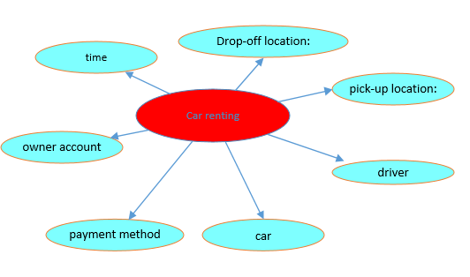

**Sell** **addtional service fact:**

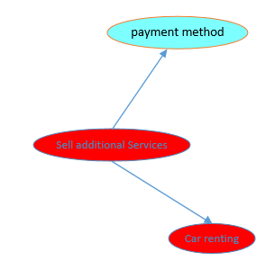

Table of facts and measure:

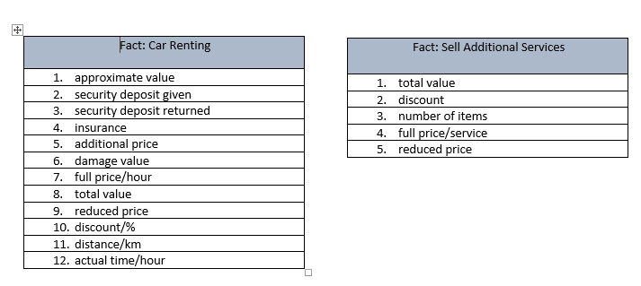

1. Database structure of data warehouse

This chapter should contain the diagram, which presents the fact tables, dimension tables and relationships between them. Additionally, every table has to be defined by:

the detailed list of columns (column name),

primary key,

foreign key in fact table(s) and optionally in dimension tables.

The diagram should be prepared using the star or snowflake data model (choose one of them).

Snowflake scheme of Car Renting:

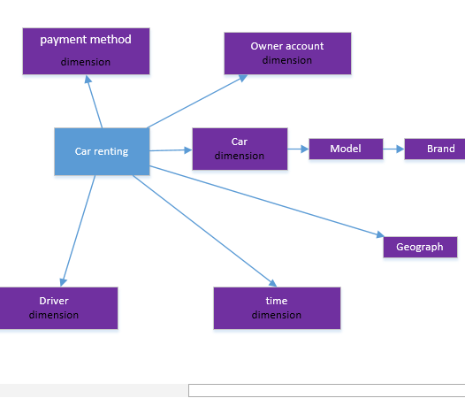

Snowflake scheme of Sell Additional Services:

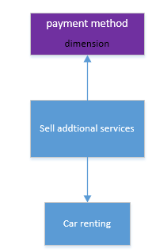

Database of the Project:

